.

[02-OperatorsinPython](https://www.rajalakshmicolleges.net/moodle/course/view.php?id=84&section-2)

**DeptofArtificialIntelligenceandMachineLearning**|**RajalakshmiEngineeringCollege**

19

**Ex.No. : 2.1 Date:9/3/24**

**RegisterNo.:231501042 Name: Dinesh Karthik K**

# [WidgetsandGizmos](https://www.rajalakshmicolleges.net/moodle/mod/quiz/view.php?id=5695)

Anonlineretailersellstwoproducts:widgetsandgizmos.Eachwidgetweighs 75grams.Eachgizmoweighs112grams.Writeaprogramthatreadsthenumber of widgets and the number of gizmos from the user. Then your program should compute and display the total weight of the parts.

SampleInput 10

20

SampleOutput

Thetotalweightofallthesewidgetsandgizmosis2990grams.

## Forexample:

|  |  |
| --- | --- |
| **Input** | **Result** |
| 10  20 | Thetotalweightofallthesewidgetsandgizmosis2990grams. |

**PROGRAM**

widgets=int(input()) gizmos = int(input())

widget_weight=widgets*75 gizmo_weight=gizmos*112

total_weight=widget_weight+gizmo_weight

print("Thetotalweightofallthesewidgetsandgizmosis{} grams.".format(total_weight))

.

**DeptofArtificialIntelligenceandMachineLearning**|**RajalakshmiEngineeringCollege**

20

**Output:**

.

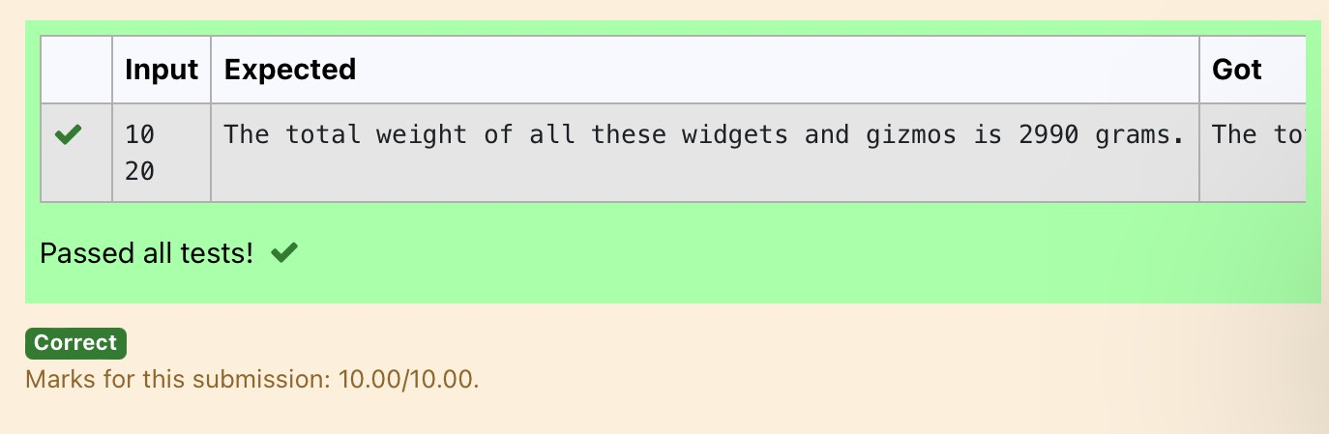

**DeptofArtificialIntelligenceandMachineLearning**|**RajalakshmiEngineeringCollege**

21

.

**Ex.No. : 2.2 Date:9/3/24**

**RegisterNo.:231501042 Name: Dinesh Karthik K**

# [DollSings](https://www.rajalakshmicolleges.net/moodle/mod/quiz/view.php?id=5696)

InLondon,everyyearduringDasaratherewillbeaverygranddollshow.Peopletry to invent new dolls of different varieties. The best-sold doll's creator will be awarded with a cash prize. So people broke their heads to create dolls innovatively. Knowingthis competition, Mr.Lokpaul tried to create a doll that sings only when an evennumberispressedandthenumbershould notbezeroand greaterthan100.

IFLokpaulwinsprinttrue,otherwisefalse.

SampleInput 10

SampleOutput True

Explanation:

Since10isanevennumberandanumberbetween0and100,Trueisprinted

**PROGRAM**

number=int(input())

if number % 2 == 0 and number != 0 and number <= 100: print("True")

else:

print("False")

**DeptofArtificialIntelligenceandMachineLearning**|**RajalakshmiEngineeringCollege**

22

**Output:**

.

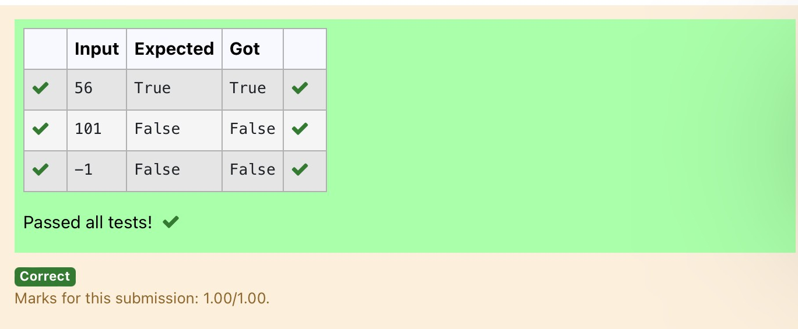

**DeptofArtificialIntelligenceandMachineLearning**|**RajalakshmiEngineeringCollege**

23

**Ex.No. : 2.3 Date:9/3/24**

.

**RegisterNo.:231501042 Name: Dinesh Karthik K**

# [BirthdayParty](https://www.rajalakshmicolleges.net/moodle/mod/quiz/view.php?id=5697)

Mr. X's birthday is in next month. This time he is planning to invite N of his friends. Hewantstodistributesomechocolatestoallofhisfriendsaftertheparty.Hewentto a shop to buy a packetofchocolates. At thechocolate shop,4 packetsare therewith different numbers of chocolates. He wants to buy such a packet which contains a numberofchocolates,whichcanbedistributedequallyamongallofhisfriends.Help Mr. X to buy such a packet.

InputGiven:

N-Nooffriends

P1,P2,P3ANDP4-Noofchocolates

OUTPUT:

"True"ifhecanbuythatpacketand"False"ifhecan'tbuythatpacket.

SAMPLEINPUTANDOUTPUT: 5

25

12

10

9

OUTPUT

TrueFalseTrueFalse

**DeptofArtificialIntelligenceandMachineLearning**|**RajalakshmiEngineeringCollege**

24

**PROGRAM**

.

N = int(input()) P1=int(input()) P2=int(input()) P3=int(input()) P4=int(input())

forpacketin[P1,P2,P3,P4]: if packet % N == 0:

print("True",end="") else:

print("False",end="")

Output:

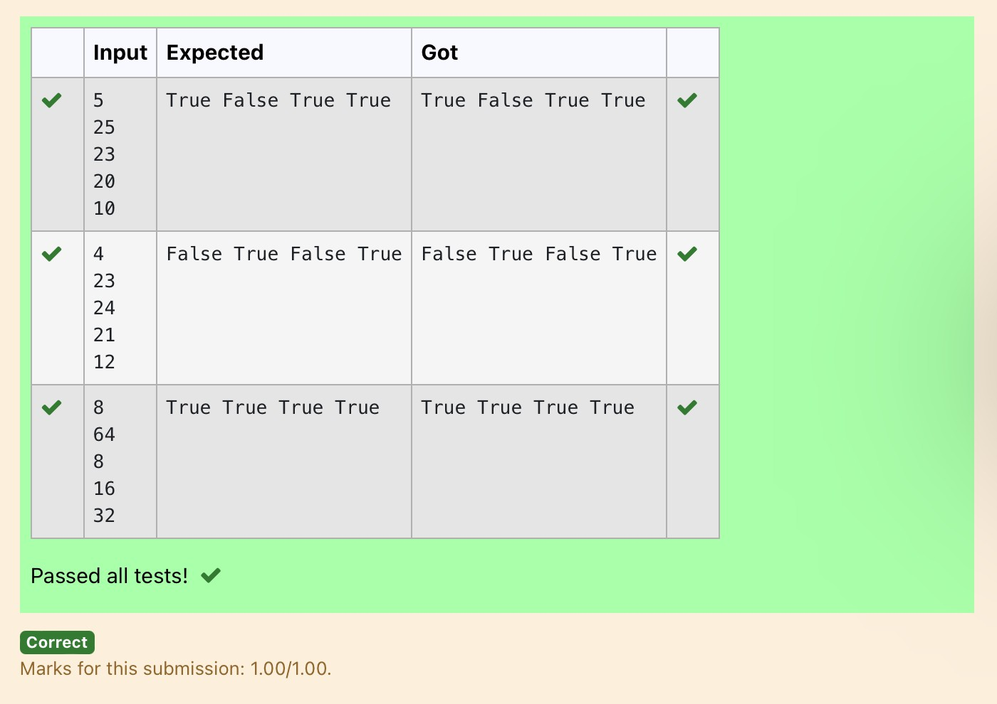

**DeptofArtificialIntelligenceandMachineLearning**|**RajalakshmiEngineeringCollege**

25

**Ex.No. : 2.4 Date:9/3/24**

.

**RegisterNo.:231501042 Name: Dinesh Karthik K**

# [HammingWeight](https://www.rajalakshmicolleges.net/moodle/mod/quiz/view.php?id=5698)

Writeapythonprogramthattakesaintegerbetween0and15asinputanddisplays the number of '1' s in its binary form.(Hint:use python bitwise operator.)

SampleInput 3

SampleOutput:

2

Explanation:

Thebinaryrepresentationof3is011,hencethereare2onesinit.sotheoutputis2.

**PROGRAM**

num=int(input()) count = 0

whilenum:

count+=num&1 num >>= 1

print(count)

Output:

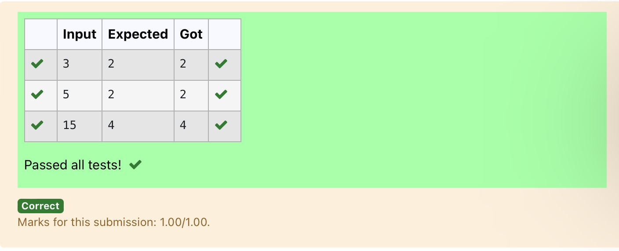

**DeptofArtificialIntelligenceandMachineLearning**|**RajalakshmiEngineeringCollege**

26

**Ex.No. : 2.5 Date:9/3/24**

.

**RegisterNo.:231501042 Name: Dinesh Karthik K**

# [CompoundInterest](https://www.rajalakshmicolleges.net/moodle/mod/quiz/view.php?id=5699)

Pretendthatyouhavejustopenedanewsavingsaccountthatearns4percent interest peryear.Theinterestthatyouearnispaidattheendoftheyear,andis added to the balance of the savings account. Write a program that begins by readingthe amount of money deposited into the account from the user. Then your program should compute and display the amount in the savings account after 1, 2, and 3 years. Displayeachamountsothatitisroundedto2decimalplaces.

.

SampleInput:

10000

SampleOutput:

Balance as of end of Year 1: $10400.00. Balance as of end of Year 2: $10816.00. Balance as of end of Year 3: $11248.64

**PROGRAM**

principal = float(input()) interest_rate = 0.04

balance_year1 = principal * (1 + interest_rate) balance_year2=balance_year1*(1+interest_rate) balance_year3=balance_year2*(1+interest_rate)

print("Balance as of end of Year 1: ${:.2f}.".format(balance_year1)) print("Balance as of end of Year 2: ${:.2f}.".format(balance_year2)) print("BalanceasofendofYear3:${:.2f}.".format(balance_year3))

**DeptofArtificialIntelligenceandMachineLearning**|**RajalakshmiEngineeringCollege**

27

**Output:**

.

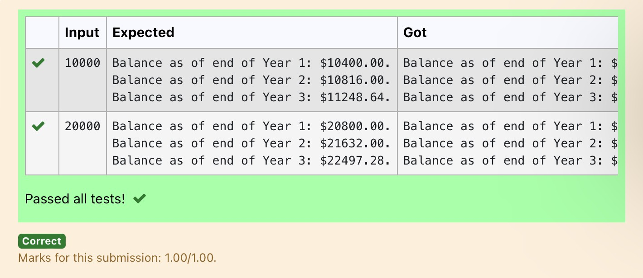

**DeptofArtificialIntelligenceandMachineLearning**|**RajalakshmiEngineeringCollege**

28

**Ex.No. : 2.6 Date:9/3/24**

**RegisterNo.:231501042 Name: Dinesh Karthik K**

# Eligibletodonateblood

A team from the Rotract club had planned to conduct a rally to create awareness amongtheCoimbatorepeopletodonateblood.Theyconductedtherallysuccessfully. ManyoftheCoimbatorepeoplerealizeditandcameforwardtodonatetheirbloodto nearby blood banks. The eligibility criteria for donating blood are people should be aboveorequalto18andhis/herweightshouldbeabove40.Therewasahugecrowd andstaffinthebloodbankfounditdifficulttomanagethecrowd.Sotheydecidedto keep a system and ask the people to enter their age and weight in the system. If a person is eligible he/she will be allowed inside.Write a program and feed it to the system to find whether a person is eligible or not.

InputFormat:

Input consists of two integers that correspond to the age and weight of a person respectively.

OutputFormat:

Display True(IF ELIGIBLE) DisplayFalse(ifnoteligible)

SampleInput 19

45

SampleOutput True

**PROGRAM**

age = int(input()) weight=int(input())

is_eligible = (age >= 18) * (weight > 40) print(bool(is_eligible))

.

**DeptofArtificialIntelligenceandMachineLearning**|**RajalakshmiEngineeringCollege**

29

Output:

.

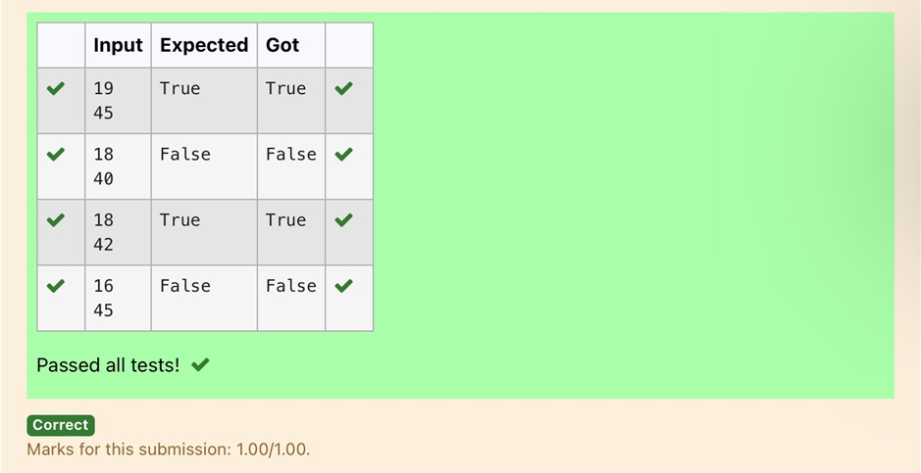

**DeptofArtificialIntelligenceandMachineLearning**|**RajalakshmiEngineeringCollege**

30

**Ex.No. : 2.7 Date:9/3/24**

.

**RegisterNo.:231501042 Name: Dinesh Karthik K**

# CorD

Mr.Ram has been given a problem kindly help him to solve it. The input of the program is either 0 or 1. IF 0 is the input he should display"C" if 1 is the input it should display"D".There is a constraint that Mr. Ram should use either logical operatorsorarithmeticoperatorstosolvetheproblem,notanythingelse.

Hint:

UseASCIIvaluesofCandD.

## InputFormat:

Anintegerx,0<=x<=1..

## OutputFormat:

outputasinglecharacter"C"or"D"dependingonthevalueofx.

**Input1:**

0

**Output1:**

C

**Input2:**

1

**Output1:**

D

**PROGRAM**

x=int(input()) if x == 0:

print(chr(ord('C'))) else:

print(chr(ord('C')+1))

**DeptofArtificialIntelligenceandMachineLearning**|**RajalakshmiEngineeringCollege**

31

**Output:**

.

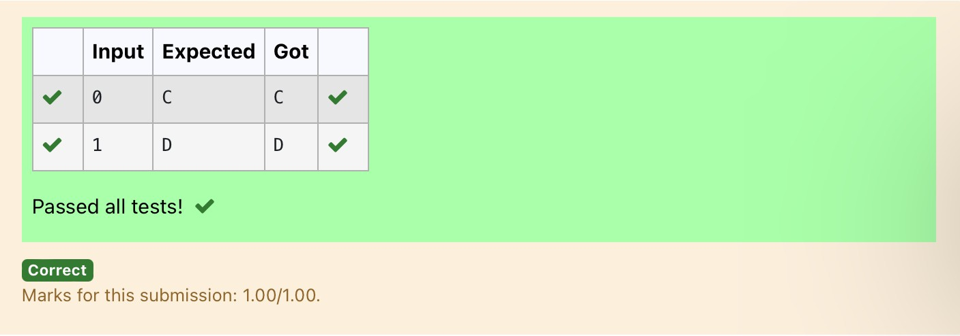

**DeptofArtificialIntelligenceandMachineLearning**|**RajalakshmiEngineeringCollege**

32

**Ex.No. : 2.8 Date:9/3/24**

**RegisterNo.:231501042 Name: Dinesh Karthik K**

# TroyBattle

Inthe1800s,thebattleofTroywasledbyHercules.Hewasasuperstitiousperson. He believed that his crew can win the battle only if the total count of the weapons in handisinmultipleof3andthesoldiersareinanevennumberofcount.Giventhe total number of weapons and the soldier's count, Find whether the battle can be wonor not according to Hercules's belief. If the battle can be won print True otherwiseprint False.

## Inputformat:

Line1hasthetotalnumberofweapons Line2hasthetotalnumberofSoldiers.

## OutputFormat:

IfthebattlecanbewonprintTrueotherwiseprintFalse.

SampleInput:

32

43

SampleOutput:'False

**PROGRAM**

weapons=int(input()) soldiers = int(input())

if weapons % 3 == 0 and soldiers % 2 == 0: print("True")

else:

print("False")

.

**DeptofArtificialIntelligenceandMachineLearning**|**RajalakshmiEngineeringCollege**

33

**Output:**

.

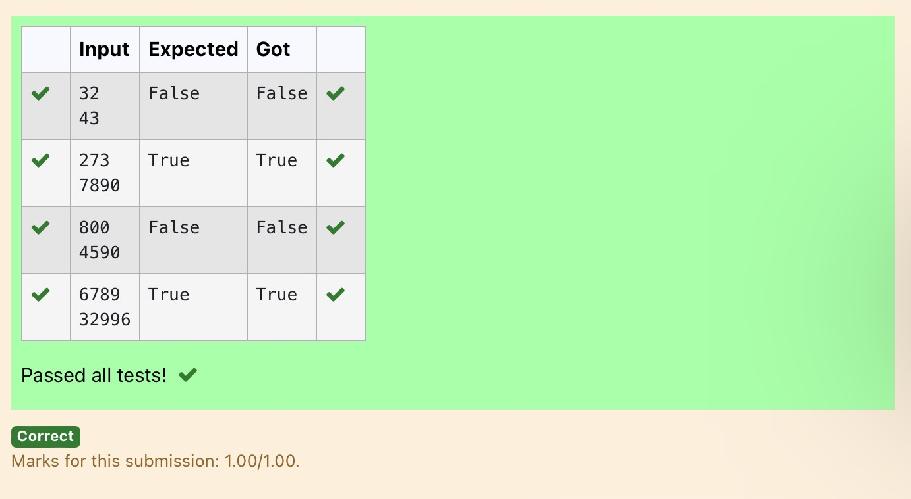

**DeptofArtificialIntelligenceandMachineLearning**|**RajalakshmiEngineeringCollege**

34

**Ex.No. : 2.9 Date:9/3/24**

.

**RegisterNo.:231501042 Name: Dinesh Karthik K**

# [TaxandTip](https://www.rajalakshmicolleges.net/moodle/mod/quiz/view.php?id=6030)

The program that you create for this exercise will begin by reading the cost of a mealorderedatarestaurantfromtheuser.Thenyourprogramwillcomputethetax andtipforthemeal.Useyourlocaltaxrate(5percent)whencomputingtheamount oftaxowing.Computethetipas18percentofthemealamount(withoutthetax).The output fromyour program should include the tax amount, the tip amount, and the grandtotalfor themealincludingboththetaxandthetip.Formattheoutputsothat all of the values are displayed using two decimal places.

SampleInput 100

SampleOutput

Thetaxis5.00andthetipis18.00,makingthe total 123.00

**PROGRAM**

cost_of_meal = float(input()) tax_rate = 0.05

tip_rate=0.18

tax_amount = cost_of_meal * tax_rate tip_amount=(cost_of_meal*tip_rate)

total_cost =cost_of_meal+tax_amount+tip_amount

print("Thetaxis{:.2f}andthetipis{:.2f},makingthetotal

{:.2f}".format(tax_amount,tip_amount,total_cost))Output:

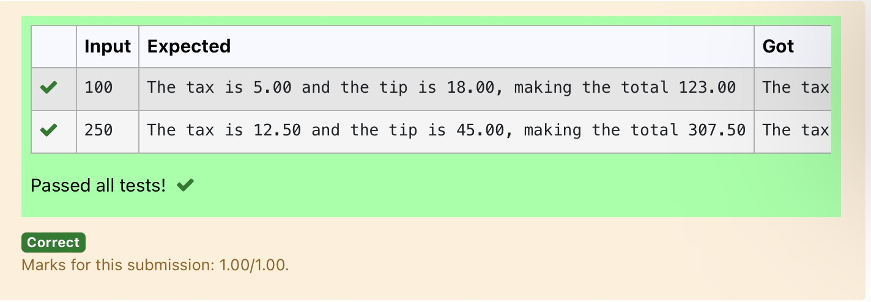

**DeptofArtificialIntelligenceandMachineLearning**|**RajalakshmiEngineeringCollege**

35

**Ex.No. : 2.10 Date:9/3/24**

.

**RegisterNo.:231501042 Name: Dinesh Karthik K**

# [Return lastdigit of the given number](https://www.rajalakshmicolleges.net/moodle/mod/quiz/view.php?id=6031)

Write a program that returns the last digit of the given number. Last digit is being referredtotheleastsignificantdigiti.e.thedigitintheones(units)placeinthegiven number.

Thelastdigitshouldbereturnedasapositivenumber.

Forexample,

if the given number is 197, the last digit is 7 ifthegivennumberis-197,thelastdigitis7 **For example:**

|  |  |
| --- | --- |
| **Input** | **Result** |
| 123 | 3 |

**PROGRAM**

number = int(input()) last_digit = abs(number) % 10 print(last_digit)

Output:

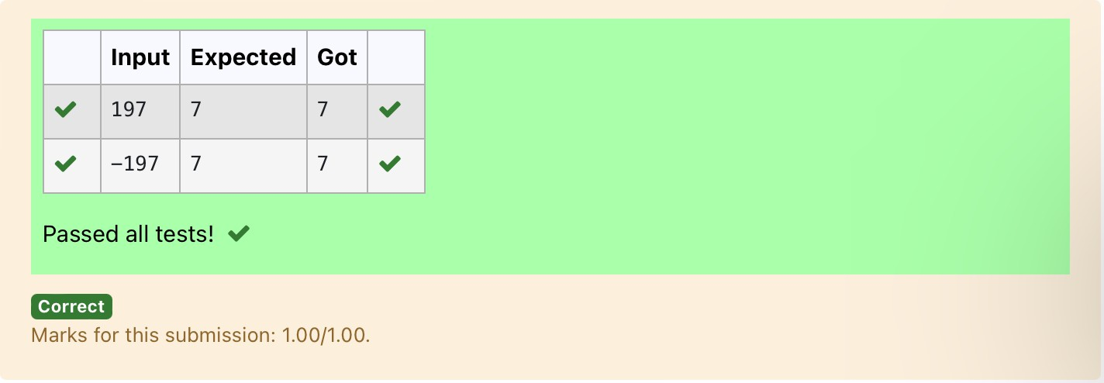

**DeptofArtificialIntelligenceandMachineLearning**|**RajalakshmiEngineeringCollege**

36